Becoming Independent…
As your child progresses through primary school, it is really important that they gain independence and learn to manage without parental support.
Here are some things you could help them with:
Dressing and Undressing

It is understandable that many parents may help their children with this to save time on a busy morning, however, this will not help in the long term. Set aside sometime, maybe after school, weekends or school holidays for your child to practise the following;
- Putting on their school uniform, including doing up buttons, fastening trousers, putting on socks and shoes.
- Practise to put clothes on the right way around and how to check it is correct.
- Learn to tie shoe laces
- Learn how to turn clothes from inside out
- Put on and zip up coats
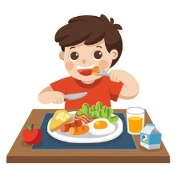
Eating
It is important that children can feed themselves. Take time to practise using a knife and fork correctly. Allow children to explore new flavours and textures. Can your child open and refill their water bottle?
Organisation
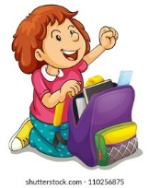
Try to encourage your child to be independent when checking what they need for the day. Instead of giving them what they need or even carrying it for them, let then think what they need and put it by the door or in the car themselves. E.g. they need to remember: their bag, lunchbox, water bottle and coat. This will help them remember what they need to take home at the end of the day. Please help your child with this by labelling all personal items.

These simple tips should help your child develop essential life skills from an early age. When the children can be independent they gain self-esteem. It might even make your mornings run more smoothly!

Any further tips or advice on independence, please speak to Mrs Galvin at school.

