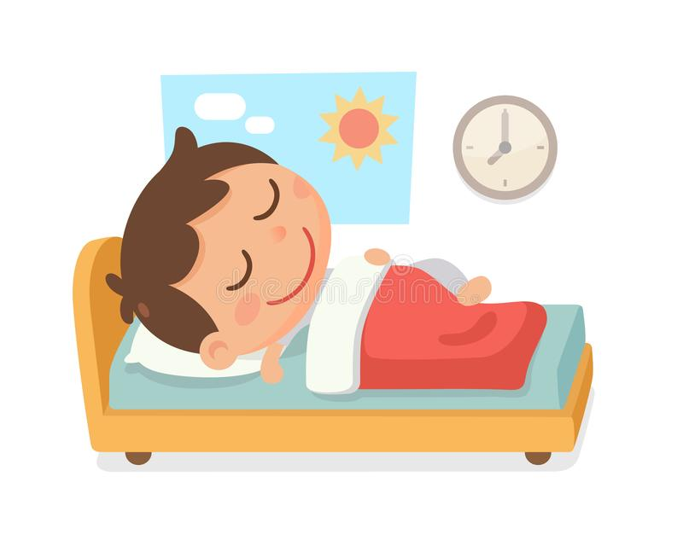
Getting a Good Night’s Sleep
Many children (and adults) find it difficult to relax at night and ready
themselves for a good night’s sleep. Sleep is SO important for our mental
and physical health and if well rested, children have a better capacity to
learn.
Doing the same relaxing things in the same order at the same time each
night help promote good sleep;
- A warm (not hot) bath, maybe with some lavender bath oil/bubble bath or wash will help your child get ready for sleep.
- Keeping the lights dim encourages your child’s body to produce the sleep hormone, melatonin.
- Once in bed, share a book together or encourage them to read (if older) or listen to some relaxing music or a story CD.
- You could also try some mindfulness activities or breathing techniques (YouTube has some great ideas).

How much sleep does my child need?
Age 3 – 5 years old | Age 6 – 12
10 – 13 hours (including naps) | 9 – 12 hours

TOP TIPS FOR A TERRIFIC NIGHT’S SLEEP…

Avoid screens in the bedroom
Tablets, smartphones, TVs and other electronic gadgets can affect how easily children get to sleep, the blue light they admit can stimulate the brain and therefore reduce the sleep hormone, melatonin.
Older children may also stay up late or even wake in the middle of the night to use social media.
Try to keep your child's bedroom a screen-free zone, and get them to charge their phones/tablets in another room.
Encourage your child to stop using screens an hour before bedtime.

Your child's bedroom
Your child's bedroom should ideally be dark, quiet and tidy. It should be well ventilated and kept at a temperature of about 16 to 20C.
Fit some thick curtains to block out any daylight. If there's noise outside, consider investing in double glazing or, for a cheaper option, offer your child earplugs.
Further Ideas and Advice:
https://sleepcouncil.org.uk/advice-support/sleep-advice/common-sleep-scenarios/sleep-advice-for-children/
https://www.webmd.com/parenting/bedtime-routine-tips#1
https://www.verywellfamily.com/kids-and-bedtime-routines-2634260

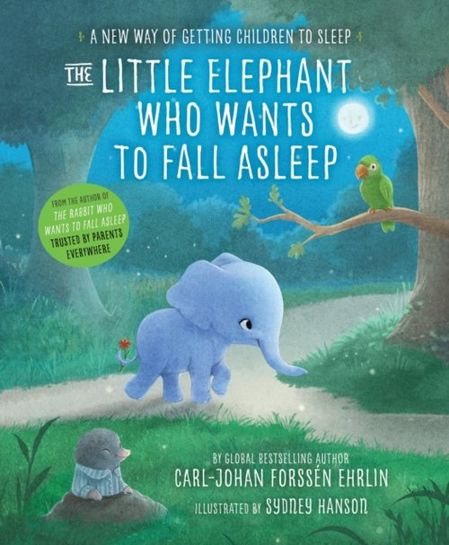
A personal favourite of mine and one I have used with my own children is – The Rabbit Who Wants to Fall Asleep. This is a book, audio CD or it can be found on YouTube. It has been written by psychologists and the language used, the voice/tone in the audio CD, along with the sentence structure, helps children to feel calm and relaxed. There is also a different story, from the same author, called The Little Elephant Who Wants to Fall Asleep.
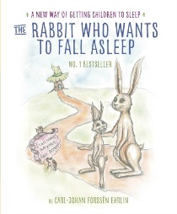

Good Luck! Remember, I am always here for any questions, help or advice.
Mrs Liz Galvin
Pastoral Lead
mrsg@holyroodprimary.co.uk

