Wise Men | Me
What they wore…. | What I wear…
How they travelled? | How I travel?
The gifts they brought… | The gifts I bring
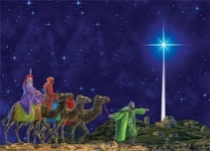
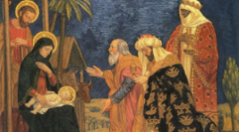
Visiting a Baby

