The Calming of the Storm

How do you think the Disciples felt during the storm? Can you write them around the picture? Then in a different colour how did they feel after the storm?

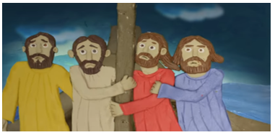

Imagine you are one of the Disciples on board the boat. What questions would you ask Jesus?

