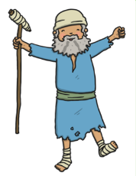

Recount of the Miracle of the Blind Man
miracle Jesus blind beggar Siloam

