
Friday 8th January 2021
I can accurately use expanded noun phrases including a comma
Target Lesson
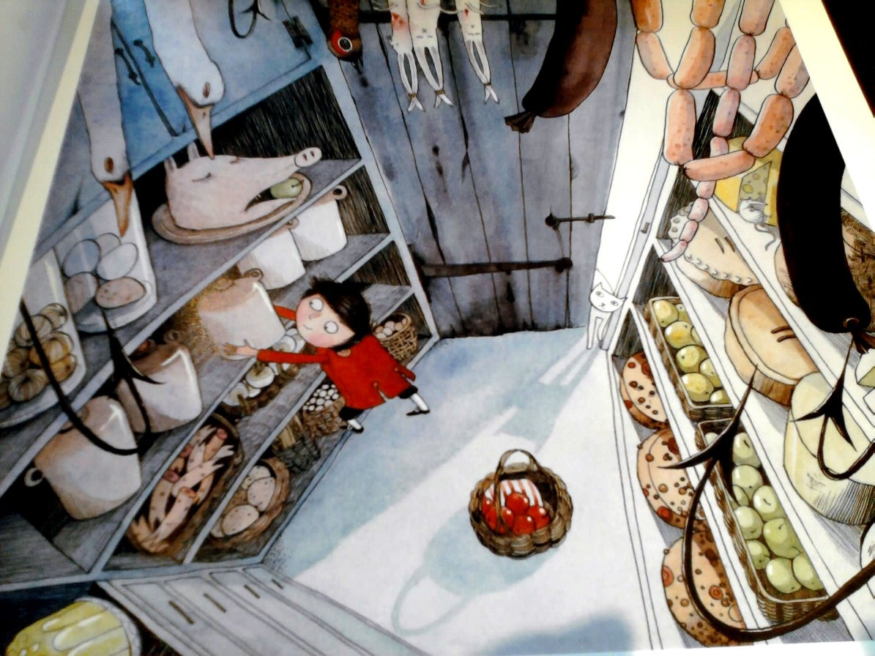

Examples- On the top shelf I can see a delicious, freshly baked pie. The juicy, ruby red apples sit patiently in the basket.

