
Friday 8th January 2021
I can use a range of conjunctions to extend my sentences. (and, but, or)
Target Lesson

Complete the sentences below applying the correct coordinating conjunction.

Little Red should lift the jar carefully the jar will smash.
The meat smelt awful the fruit was going off too.
The Wolf had lots of food he wanted to eat Grandma instead.
Write your own sentences about the picture below applying the coordinating conjunctions in the box. Can you show that you can use all three?
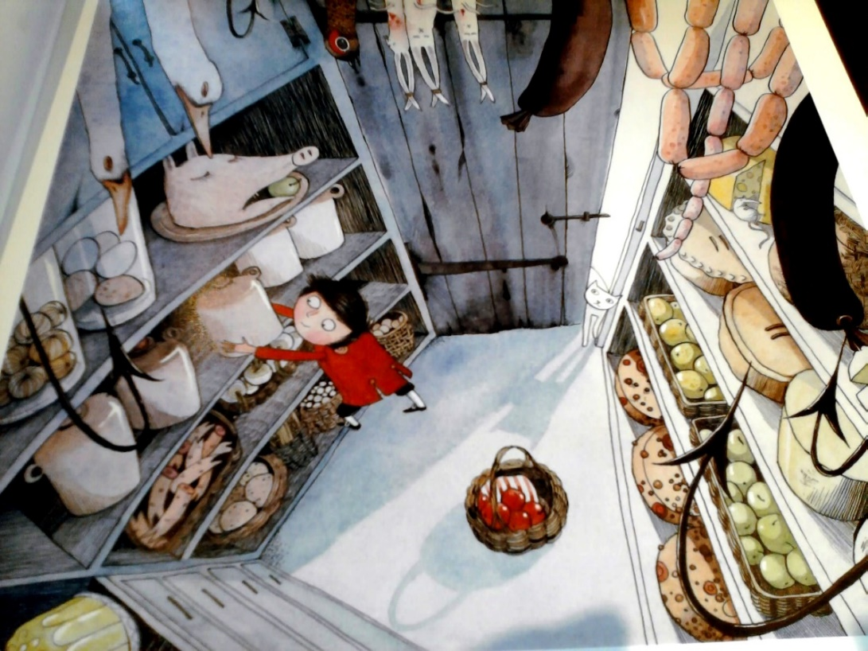

Coordinating Conjunctions

and
but
or

