
Friday 8th January 2021
I can accurately use capital letters and full stops independently.
Target Lesson
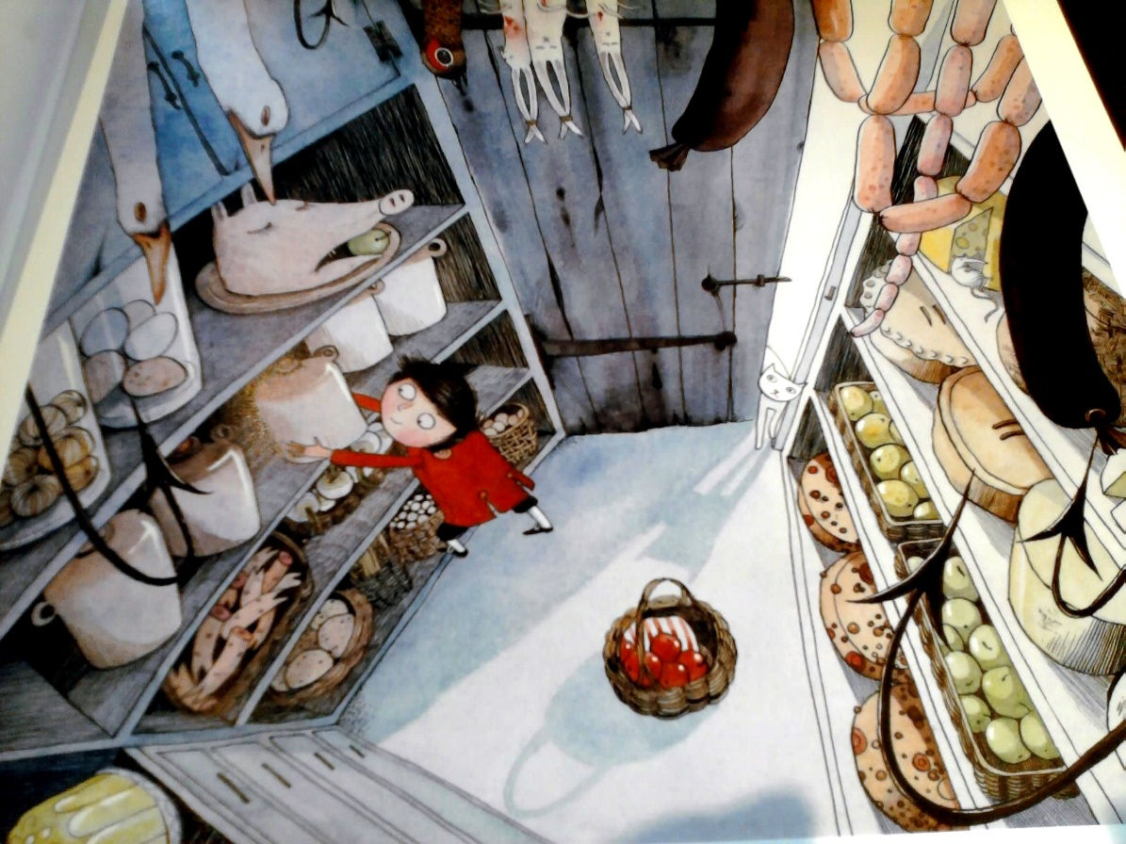

The red apples are in the bottom of the basket. A tasty pie smells delicious.

