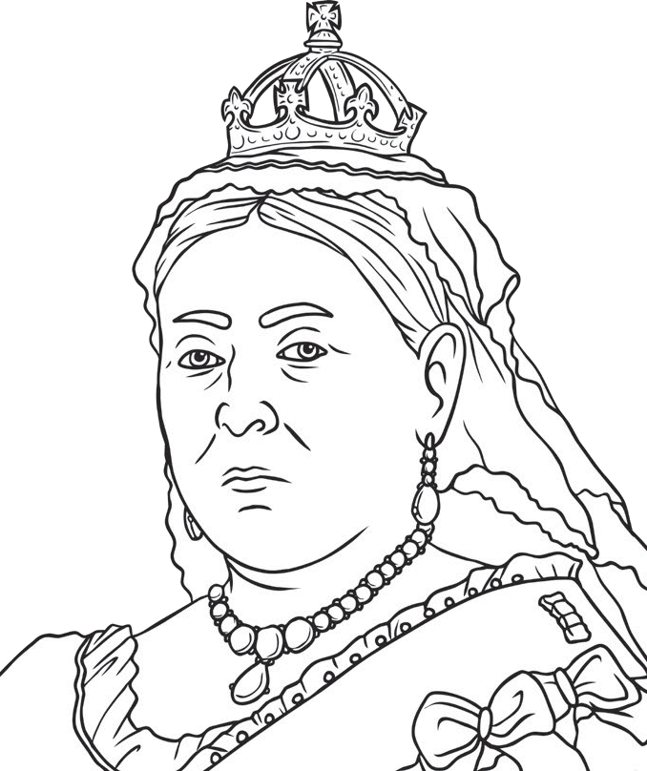
What would I have asked Queen Victoria?
Queen Victoria

A picture of Queen Victoria

What I found out about Queen Victoria

Date of birth: Date of death:

