Appearance

strange / strangely extreme / extremely

wonderful / wonderfully

usually always sometimes never

hairy large blue grey soft short sharp

long tall dark light curved flat

thin deep hollow shallow

Challenge- Subordinating conjunctions to extend descriptions
e.g. He has long, floppy ears so that he can hear over great distances .
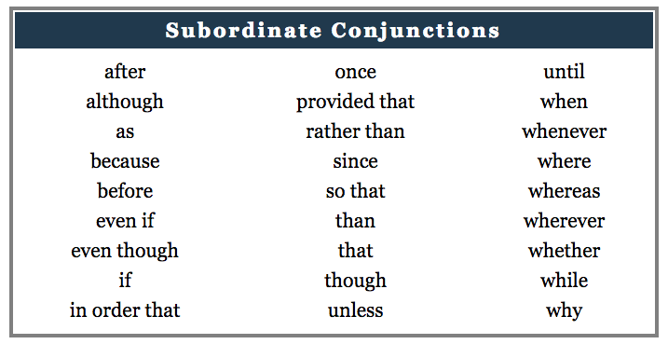

Personality
Snortle is a… He is a … This… He is… Sometimes he… Often he…
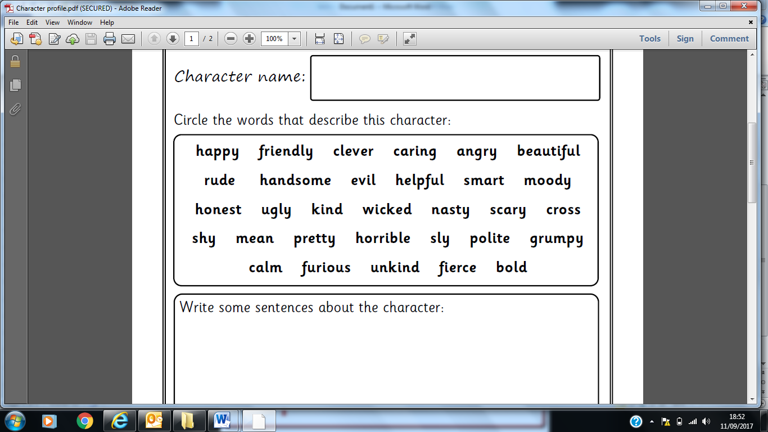

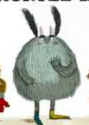
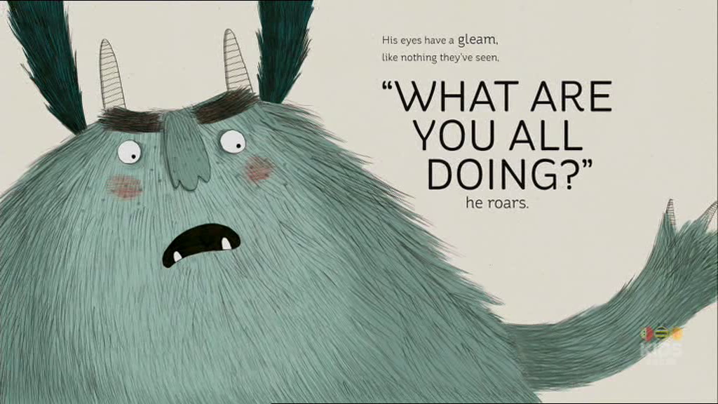
Character Profile - The Snortle

