
Thursday 25th February 2021
I can accurately use capital letters and full stops independently.
Target Lesson
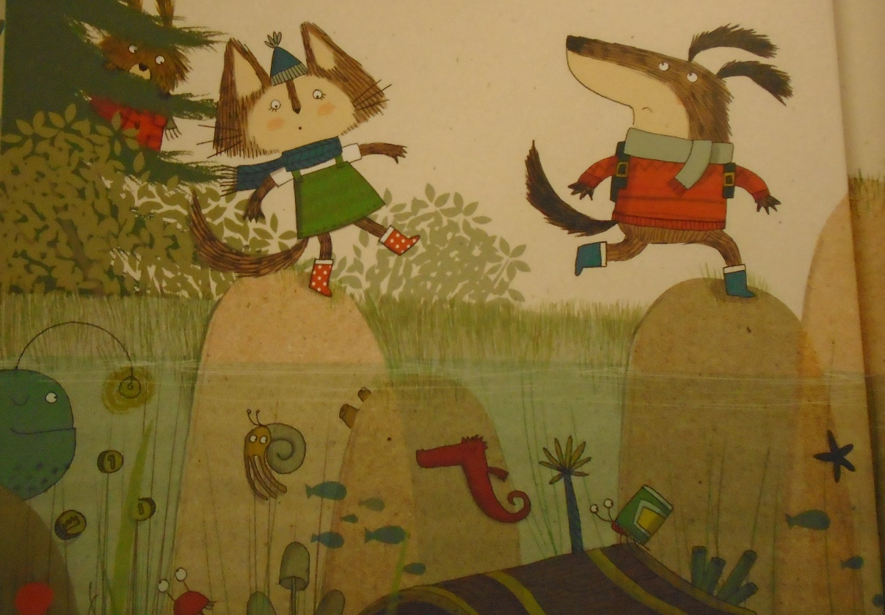

The animals went on an adventure. Dog jumped across first.

