
Thursday 25th February 2021
I can accurately use expanded noun phrases including a comma
Target Lesson
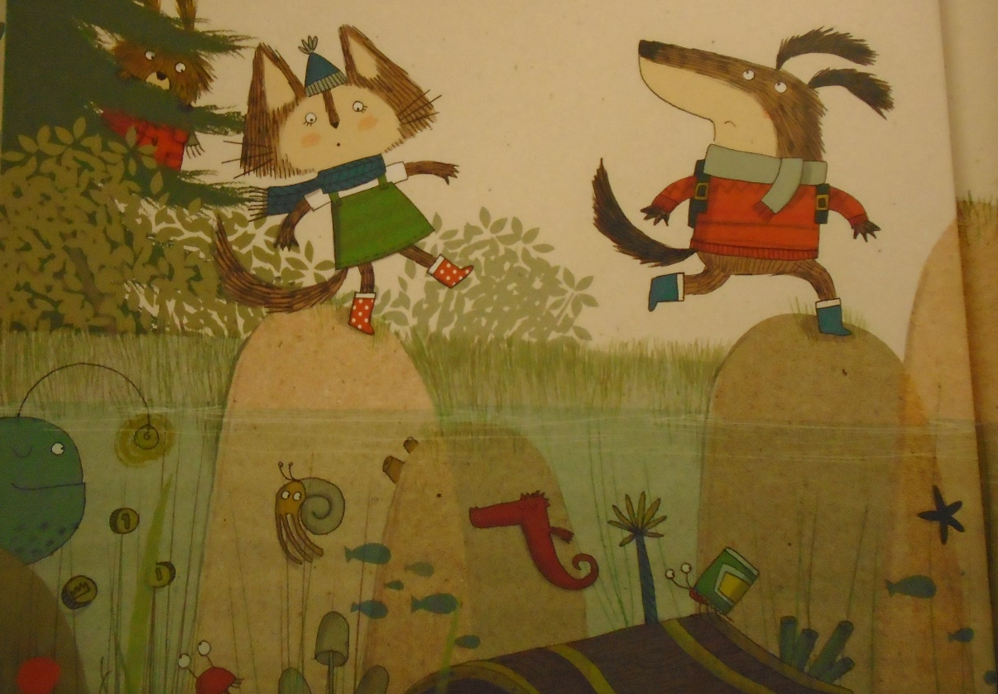

Example- Cat jumped across the hard, rough rocks.

