
Thursday 25th February 2021
I can use a range of conjunctions to extend my sentences.
Target Lesson

Complete the sentences below applying the correct conjunction: and, or, but, so, because, if
Cat was worried she couldn’t swim.
The water was deep the animals had to step carefully.
Dog went first cat could watch how it was done.
Rabbit hid in the bush watched from afar.
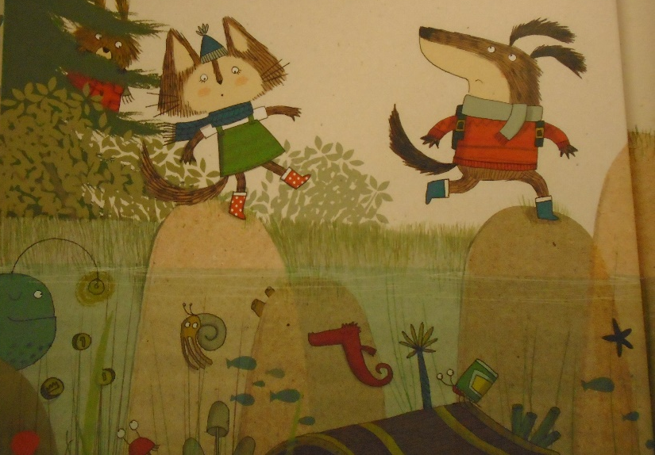
Coordinating Conjunctions
and
but
or
so

Subordinating Conjunctions
because
if

Write 7 of your own sentences about the picture below applying a range of subordinating and coordinating conjunctions in the boxes above.

