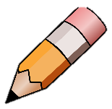
Punctuation- Commas

Complete the sentence below to show your understanding.

A comma can be used to

A comma can also be used when

Edit the sentences below to show where the commas need to be.

Mouse could see tree a long path and a pond.
Dog was afraid of the dark so he took a torch a teddy and his friends.
Challenge
Cat wore her dress and a hat and a scarf and her boots.

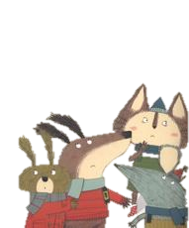
Imagine you were going on a Snortle Hunt. Use the picture below to write 4 of your own sentences applying commas in a list.


