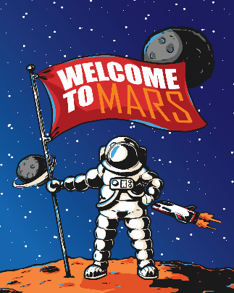

Jack and his dog are going on a mission to Mars!
You need to pack their suitcase with everything they need to
survive and some things to make them happy.

Things they will need to survive on Mars | Things that will make them happy

