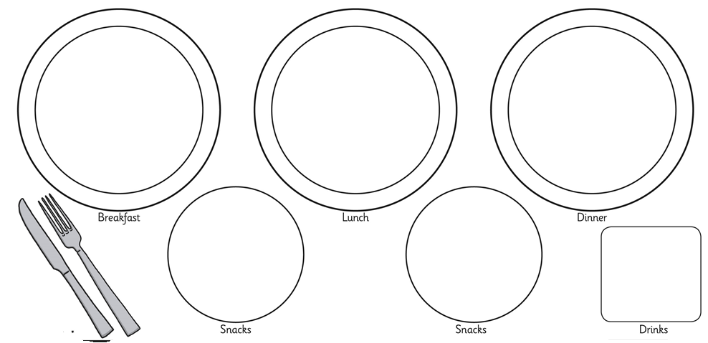
My meal plan is healthy because ____________________________________________________________________________________________________________________________________________________________________________________________________________________________________________________________________________________________________________________________________________________________________________________________________________________________________

