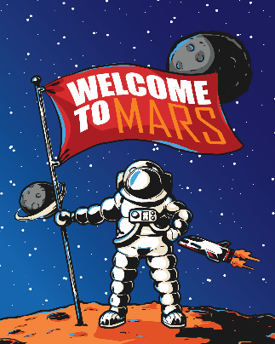

What does Jack need on his rocket ship to keep him clean and healthy
in space?

___________________________


___________________________
Why is hygiene important for humans?
______________________________________________________________________________________________________________________________________________________________________________________________________________________________________________________________________________________________________________________________

___________________________

___________________________

___________________________

___________________________

