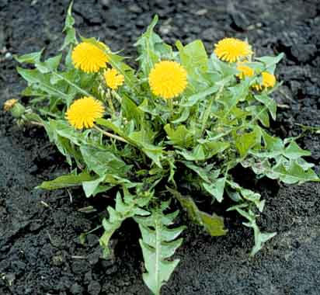
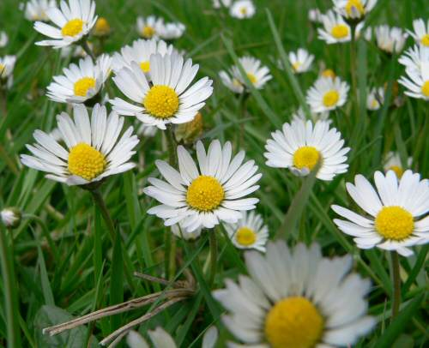
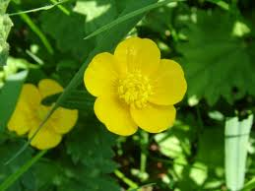
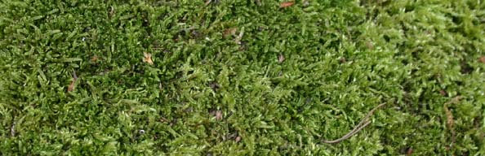
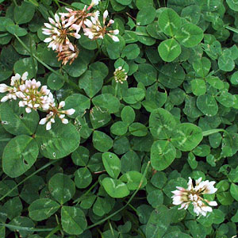
A Dandelion. How many did you see? Where did you see it? Describe it.
____________________________________________________________________________________
Daisies. How many did you see? Where did you see it? Describe it.
____________________________________________________________________________________
Clover leaves. How many did you see? Where did you see it? Describe it.
____________________________________________________________________________________
Moss. How much did you see? Where did you see it? Describe it.
____________________________________________________________________________________
Buttercups. How many did you see? Where did you see it?
____________________________________________________________________________________

