A Virtual School Trip to the Zoo!
Although we are currently unable to go on a school trip, we are not going to let that stop us! We are all going to go on a virtual school trip from the comfort of our home to Chester Zoo!

Firstly, head to the Chester Zoo website:
https://www.chesterzoo.org/virtual-zoo-2/
Scroll down until you find the virtual zoo section.
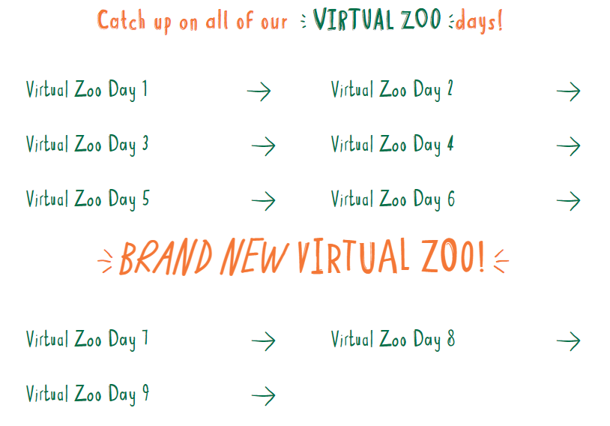

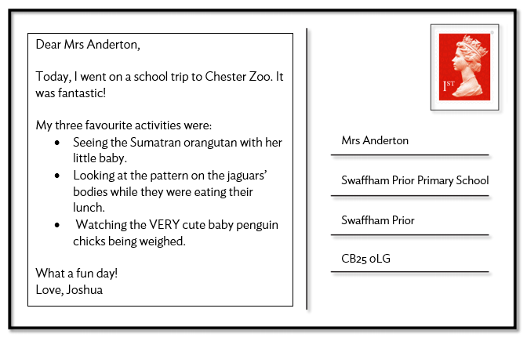
Now, take your time to explore the zoo. Watch the virtual zoo day videos, look at the photographs of the animals they have at the zoo and generally explore the website like you would explore each section of the zoo if you were there.
Finally, send a postcard to your teacher from Chester Zoo sharing your three best activities.

