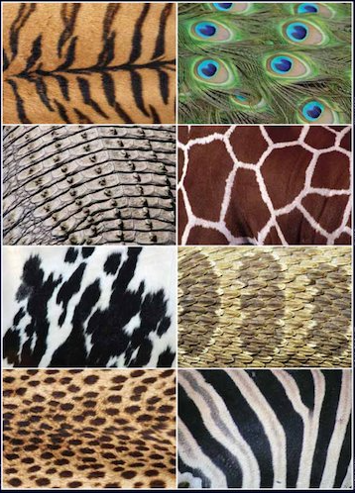
Zoomed-in Photo Competition
Can you guess the animals from the patterns in the photos?
2.
4.
6.
8.
3.
1.
7.
5.

