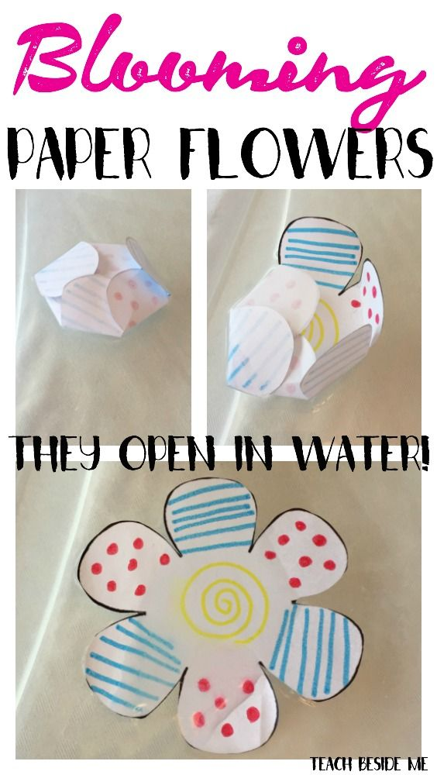
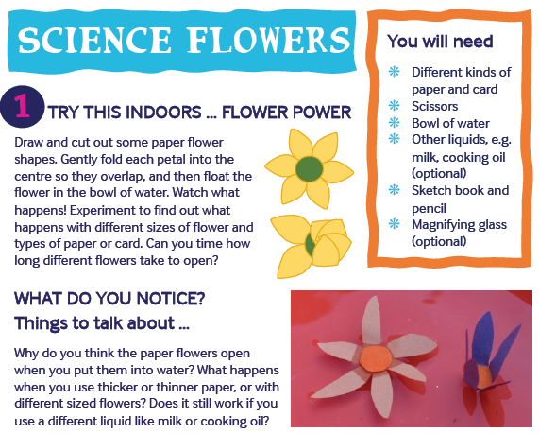
Step 1. Create a paper flower
Step 2. Fold the petals into the middle.
Step 3. Put your flower on top of a bowl of water. Watch what happens!


