
L2 Deepen it- Multiplication

Find the missing digits.

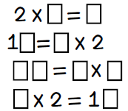
Can you solve the calculations using the digits
0, 1, 2, 3, 4, 5, 6, 7, 8, 9 only once.

