Do it
What numbers are the arrows pointing to?
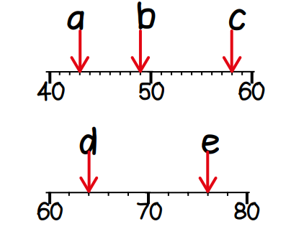
a =
b =
c =
d =
e =
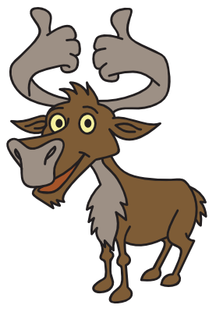
Secure it
Key words
Scale
Division of
Ones twos

Colin thinks the arrow is pointing to 33.
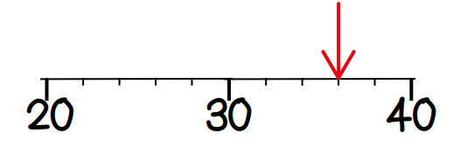

Explain why he is incorrect.

What is the correct answer?

