Do it
What numbers are the arrows pointing to?
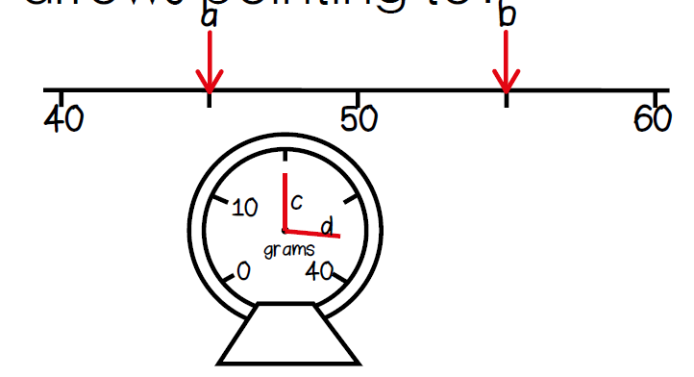
B
A
a =
b =
c =
d =

Secure it
Colin thinks the arrow is pointing to 30.
Key words
Scale
division of
fives tens

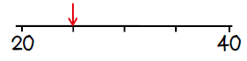

Explain why he is incorrect.

What is the correct answer?

