Do it Measure the lengths of each object.
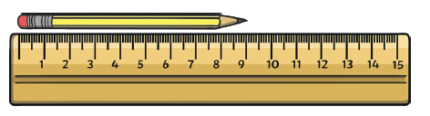 | 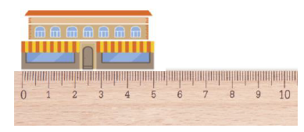
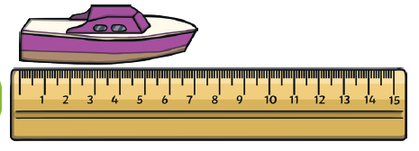 | 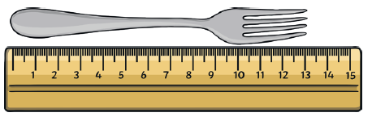
Secure it
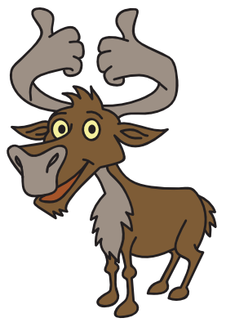
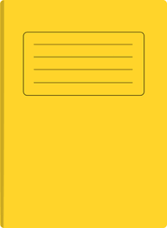

Colin thinks the maths book is 30 metres long.
Key words
Unit of measure
Length
Metres centimetres

Explain why he is incorrect.
What is the correct answer?

