Do it
Measure the height of each tree.
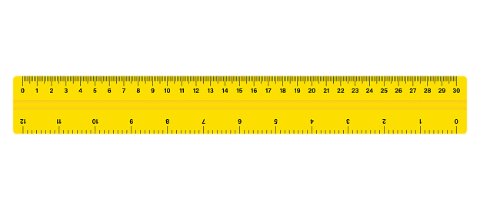  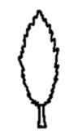 | 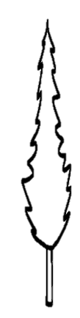
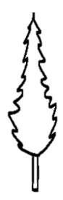 | 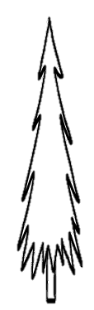
Find two objects of your own to measure the height of

1.
2.

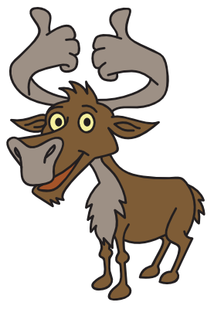
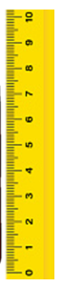
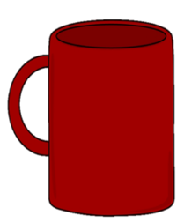
Secure it

Coco thinks that his mug is 9cm tall.

Key words
Measure
Height
cm scale

Explain why he is incorrect.

What is the correct answer?

