Do it
Find $\frac{2}{4}$ of the following numbers of cubes.
$\frac{2}{4}$ of 12 cubes is _______   | $\frac{2}{4}$ of 20 cubes is _______ | $\frac{2}{4}$ of 8 cubes is _______
$\frac{2}{4}$ of 4 cubes is _______ | $\frac{2}{4}$ of 16 cubes is _______ | $\frac{2}{4}$ of 24 cubes is _______
Secure it
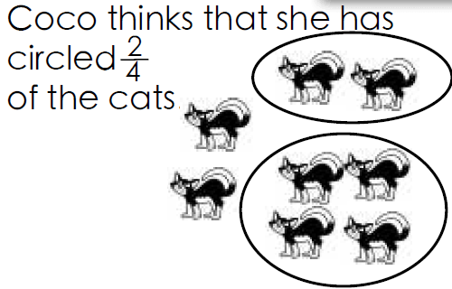
Key words
Fraction whole
Equal parts
Two quarters

Coco is incorrect. Explain why.

Coco is because I know that

The correct answer is…

