Line | Texture | Pattern
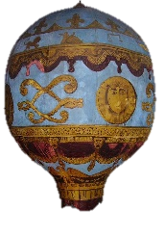
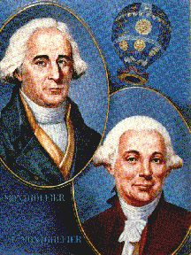
Inspired by the Montgolfier Brothers

