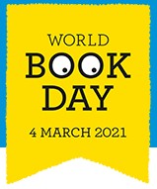
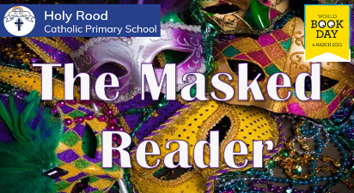
Are you up for the challenge?
Each teacher has masked their identity to share one of their favourite books with you. They have also provided a few clues to help you with your decision.

Can you identify who the Masked Reader and which favourite book they have chosen?
LKS2 (Year 3 and 4)

Teacher | Masked as… |  | Favourite Book is…
Mrs Ali
Mrs Cacchio

Miss Santos
Miss Foy

UKS2 (Year 5 and 6)

Teacher | Masked as… | Favourite Book is…
Miss Rofe
Mrs Martin
Miss Clark
Mr Westman
Mrs Forsyth



