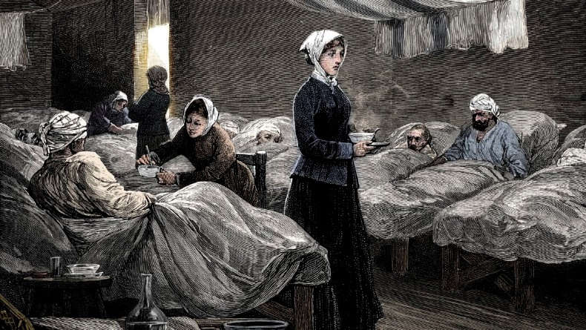
Where did she want to travel to and why?
Fun Fact-
About her family and childhood

Born-

Died-
What did Florence what to be and why?

