Happy New Year!
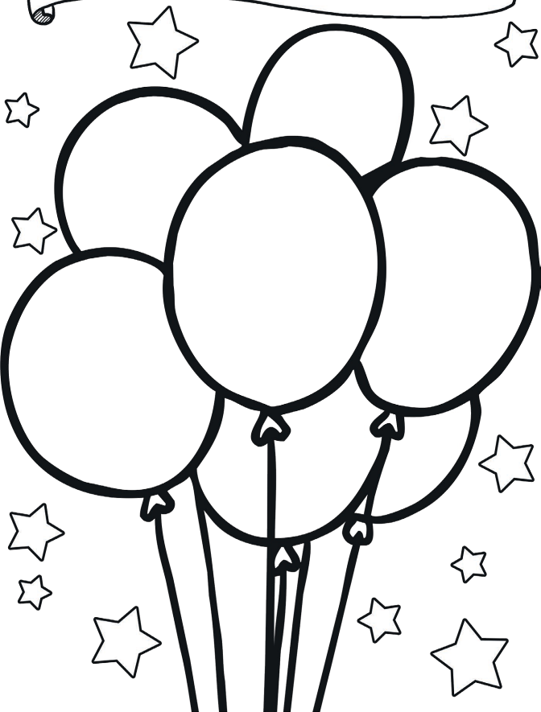

This year I want to...

One thing I would like
to do again...

My goals for this year...

This year I can’t wait to...

The best day of school last year was...

