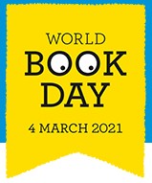
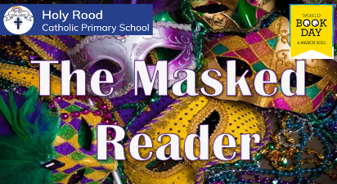
Are you up for the challenge?
Each teacher has masked their identity to share one of their favourite books with you. They have also provided a few clues to help you with your decision.

Can you identify who the Masked Reader and which favourite book they have chosen?
Reception- EYFS

Teacher | Masked as… |  | Favourite Book is…
Miss Kent
Miss Warren

Miss Evans

KS1

Teacher | Masked as… | Favourite Book is…
Miss Glennon
Miss Aimes
Miss Mendham
Mrs Kitchen



