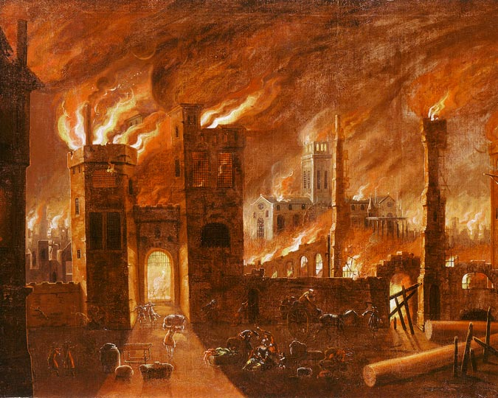
Maths
Show us that you understand the place value of 2 digit numbers.
Choose 12 numbers and partition them into tens and ones showing your written method using sticks and bricks.

For example…
45

4 sticks of 10 and 5 ones
Log onto Numbots to see if you can reach your weekly activity goal. Numbots will help you revise your number facts and know them quickly.
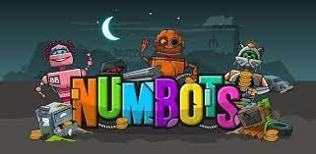

Science
In Science this term, we have been learning about everyday materials and their uses. Use the back of this sheet to complete a materials hunt around your home.

RE
We have been learning about God’s creations and the messages about how God would like us to protect what he has created.
Draw and label a picture to show how you protect God’s creations.
For example- putting litter into bins
Planting seeds to grow new plants and trees
Turning off taps to save water

English
We would like you to pretend to be the Baker from The Great Fire of London. Write a diary entry about his experience.
Think about what you can see, hear, smell and feel to set the scene.
For example…
Dear Diary,
Yesterday was an eventful day. I woke up early feeling ready for the day ahead but the events that followed were horrifying.
First I…. for you to continue

History
Design and write a fact file all about our monarch King Charles III.
Think carefully about the key facts you think people should know and features to make your fact file look interesting.
For example…
Captions, labelled pictures, timeline, title, subheading etc

Choose 2 or more subjects below and complete the task ready to share with your class on Monday 2nd December 2024. Enjoy!
Is the past the key to the future?
Year 2 - Term 1 and 2 Homework

