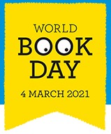
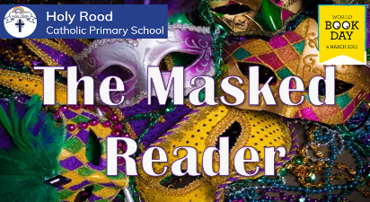
Are you up for the challenge?
Each teacher has masked their identity to share one of their favourite books with you. They have also provided a few clues to help you with your decision.

Can you identify who the Masked Reader and which favourite book they have chosen?
Reception- EYFS

Teacher | Masked as… |  | Favourite Book is…
Giraffe – Miss Kent |  | 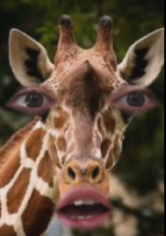 | The Little White Owl  By Tracey Corderoy
Tiger- Miss Warren |  | 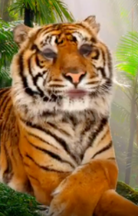 | The Selfish Crocodile  By Faustin Charles
Duck- Miss Evans |  | 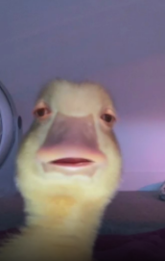 | Supertato  By Paul Linnet and Sue Hendra

KS1

Teacher | Masked as… | Favourite Book is…
Pigeon- Miss Glennon | 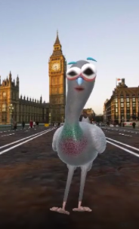 | Fantastically Great Women Who Changed the World  By Kate Pankhurts
Avocado- Miss Aimes | 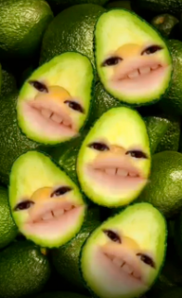 | Handa’s Surprise  By Eileen Browne
Cat- Miss Mendham | 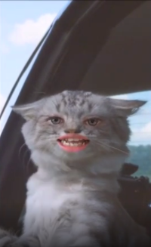 | The Snail and the Whale  By Julia Donaldson
Owl- Mrs Kitchen | 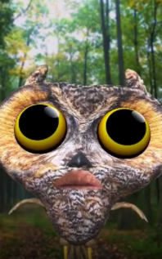 | The Smartest Giant in Town  By Julia Donaldson

LKS2 (Year 3 and 4)

Teacher | Masked as… |  | Favourite Book is…
Baby Yoda - Mrs Ali |  | 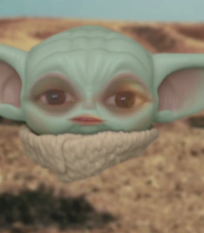 | The Twits by Roald Dahl
Pig – Mrs Masi- Cacchio |  | 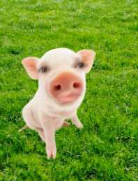 | The Sheep-Pig by Dick King-Smith
Egg - Miss Santos |  | 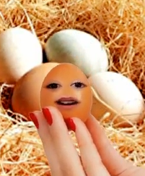 | Matilda by Roald Dahl
French Fries –  Miss Foy |  | 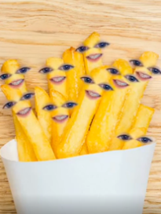 | Revolting Rhymes by Roald Dahl

UKS2 (Year 5 and 6)

Teacher | Masked as… | Favourite Book is…
Pineapple - Miss Rofe | 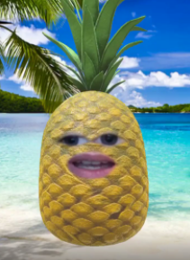 | The Rainbow Fish by Marcus Pfister
Frog - Mrs Martin | 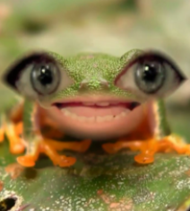 | Pippi Longstocking by Astrid Lindgren
Snowy Owl - Miss Clark | 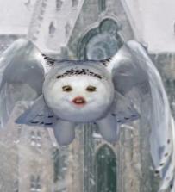 | Harry Potter & the Philsopher’s Stones by J.K. Rowling
Highland Cow –  Mr Westman | 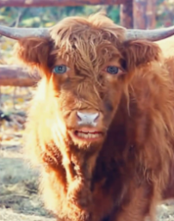 | Holes by Louis Sachar
Kermit the Frog - Mrs Forsyth | 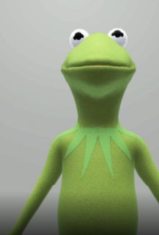 | Percy the Park Keeper by Nick Butterworth

Bonus Round

Teacher | Masked as… | Favourite Book is…
Polar Bear – Miss Fry | 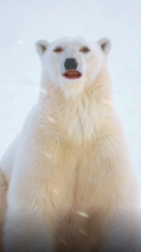 | Harry Potter and the Philosopher’s Stone  By J.K Rowling
Sloth – Miss Thomas | 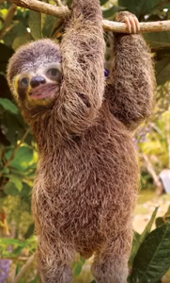 | My Brother is a Superhero  By David Solomons

