Do it
Calculate and represent:
10 + = 11
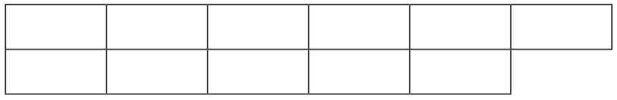

2 + = 11

11 = 3 +
Show me
Can you find the other addition facts for 11 and write them in your book?

11 = 7 +

11 = 5 +

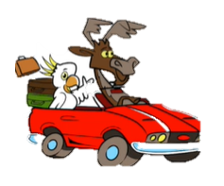

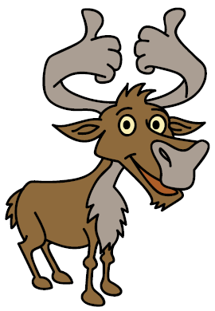
Secure it
Colin thinks that 1 and 1 make 11.
3434
44
34
44
54

Key words
10
1
11

Repeating

Explain why he is incorrect.

Colin is incorrect because I know that if _______ is the whole and one part is ______, ______ must be the other part.

