Do it
Calculate and represent:
11 – 7 =
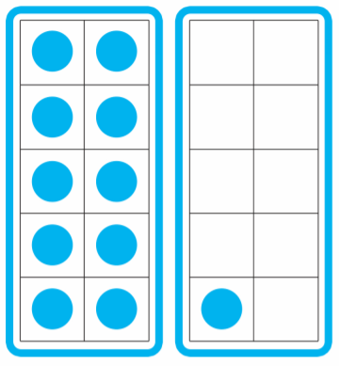

11 – 6 =

11 – 5 =
Show me
Can you find the other subtraction facts for 11 and write them in their book?

= 11 - 4

= 11 - 3


Secure it
Colin thinks that when you take away from 11, you can have 12 counters left.
3434
44
34
44
54

Key words
12
11
11
Repeating

Explain why he is incorrect.
Colin is incorrect because if ____ is the whole, it must be the largest number and I know that ____ is larger than ____.

