Do it
Calculate and represent:
10 + = 12
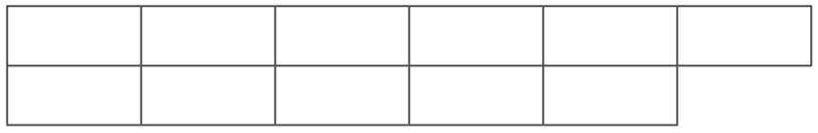

5 + = 12

12 = 9 +
Show me
Can you find the other addition facts for 12 and write them down?

12 = 6 +

12 = 3 +

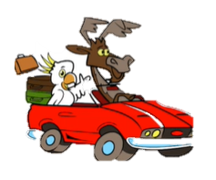

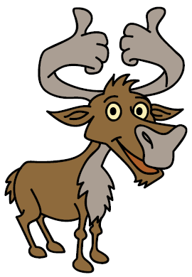
Secure it
Colin thinks that 6 6 = 6 + 12
3434
44
34
44
54

Key words
6
12
6

Repeating

Explain why he is incorrect.

Colin is incorrect because I know that _______ is the whole, one part is ______ and the other part is _____.

