Do it
Use the diagrams to represent all the ways you can subtract from 12.
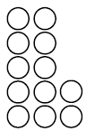
Eg. 12 – 1 = 11 Eg. 12 – 2 = 10

Show me
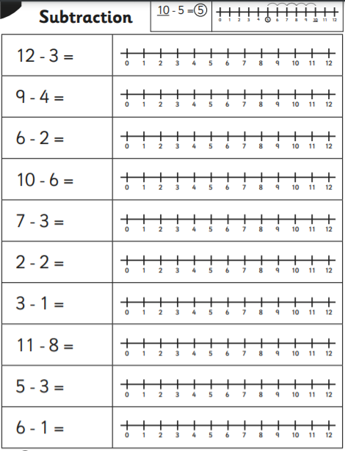

Secure it
Colin thinks that
12 = 10 - 2
3434
44
34
44
54

Key words
2
12
10
Repeating

Explain why he is incorrect.

Colin is incorrect because I know that _____ is the whole, ____ is the part that I am taking away and _____ is the part that I should have left.

