Do it
Calculate and represent:
10 + = 13
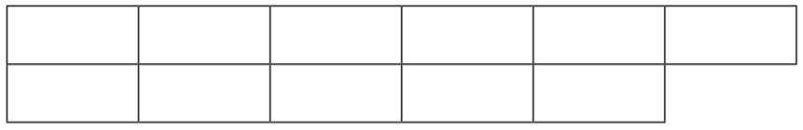

2 + = 13

13 = 8 +
Show me
Can you find the other addition facts for 13 and write them in your book?

13 = 6 +

13 = 4 +

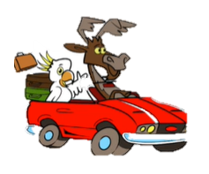

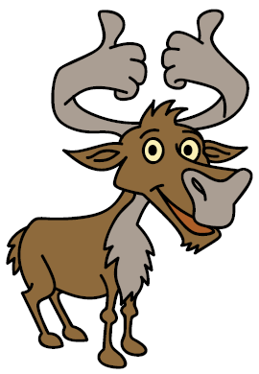
Secure it
Colin thinks that there are 12 addition facts of 13.
3434
44
34
44
54

Explain why he is incorrect.

Colin is incorrect because I know that there are ______ addition facts of 13.

