Do it
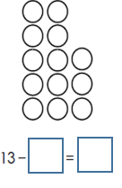

Show me
Use the last sheet to help you with the answers below.
9 = 13 -
4 = 13 -
1 = 13 -
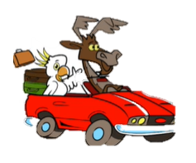
8 = 13 -
2 = 13 -
11 = 13 -
13 = 13 -
3 = 13 -

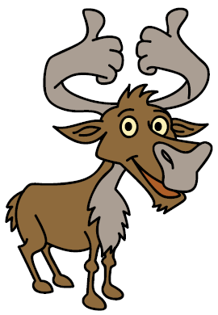
Secure it
Colin thinks that he has represented 13 – 8 = 5
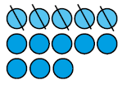
3434
44
34
44
54

Key words
13
8
5

Explain why he is incorrect.

Colin is incorrect because I know that _______ is the part that I am taking away from ______ and _______ is the part that I have left.

