Do it
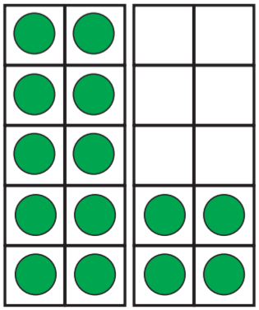
14 – 3 = ___

___ = 14 - 8

14 – 10 = ___

14 – 4 = ___

___ = 14 – ___

___ = 14 – 5

___ = 14 – ___

___ = 14 – 5

Show me
Can you find and represent all of the other subtraction facts for 14?
Key words
1
13
14

Secure it
Colin thinks:
14 – 1 = 15
3434
44
34
44
54

Explain why he is incorrect.

Colin is incorrect because I know that _______ is the part that I am taking away from ______ and _______ is the part that I should have left.
Correct number sentence:____________________________________________

