
Do it
Calculate and represent

10 + =15 4 + = 15

15 = 6 + 15 = 7 +

15 = 8 + 15 = + 9

Show it: Can you find more addition statements. Represent all the ways to show the addition number sentences to make 15.


Secure it
Key words
15
7
8


Co Colin is incorrect because I know that ___ is the whole and
Colin thinks that:
15 + 7 = 8.

Key words

Explain why he is incorrect.
Colin is incorrect because I know that _______
is the whole and the parts are ________ and
______.

facts for15.
.

The correct calculation is_____________________________________-

Deepen it:
Find the missing numbers. Solve it in different ways. Can you solve it using only 2 numbers?
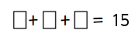
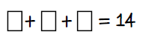
15

Show it: Can you find more addition statements. Represent all the ways to show the addition number sentences to make 15.

  
  
  
  

