
Do it
Calculate and represent

15 - 5 = 15 - 6 =

15 - 7 = =15 - 4

= 15 - 3

Show it: Can you find more subtraction facts. Represent all the ways to show the subtraction number sentences of 15.

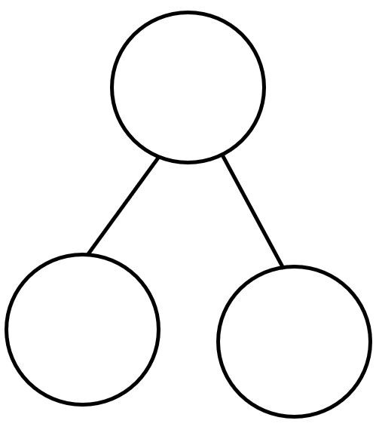
Secure it
Key words
15
10
5


Co Colin is incorrect because I know that ___ is the whole and
Colin thinks that:
10 = 5 - 15

Explain why he is incorrect.
Colin is incorrect because I know that _______ is the part that I am taking away from ______ and _______ is the part that I should have left

Correct number sentence:____________________________________________

Deepen it:
Draw a picture to represent each problem and then solve it:
- A bus has 15 passengers. 7passengers get off. How many are
left on the bus?
- There are 15 children playing football. 9 children go home. How
many are left?
- There are 15 oranges in a dish. 3 are eaten, then 2 more are eaten.
How many oranges are left?
Make up some more maths stories about 1
Show it: Can you find more subtraction statements. Represent all the ways to show the subtraction number sentences of 15.

   
   
   
   

