Do it
Complete the part-part-whole models:
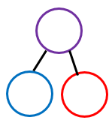  3  16 | 6  8  16  16
Colin thinks that he has partitioned 16.  3434  44  34  44  54  16  4 | Key words  3 16 13  Repeating  16  9

Secure it
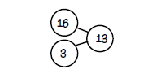

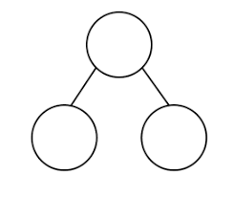
Show the correct partitioning on the part part whole model.

Explain why he is incorrect.
Colin is incorrect because I know that ___ is the whole and ____ and ____ are parts.

Show it
Can you represent all part-part whole models.
Deepen it
Ellie has 16 biscuits on a plate. The biscuits are chocolate
or plain. How many of each biscuit could she have?
Find all the different ways to solve the problem.
Convince Colin by representing your thinking with a diagram.

