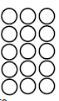
Do it
Calculate and represent
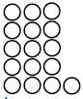
10 + =1 3 + =

16 = 5 + 16 = + 8

16 = 4 + 16 = + 9

Show it: Can you find more addition statements. Represent all the ways to show the addition number sentences to make 16.

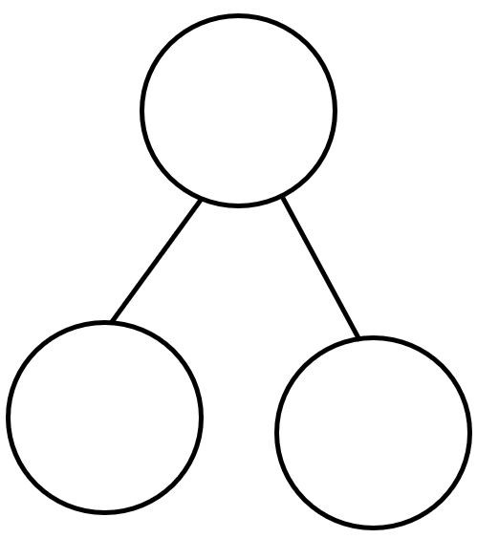
Secure it

Key words
16
7
8

Co Colin is incorrect because I know that ___ is the whole and
Colin thinks that:
10 = 6 + 16

Explain why he is incorrect.
Colin is incorrect because I know that _______
is the whole and the parts are ________ and
______.

facts for15.
.

The correct calculation is_____________________________________-
Deepen it:
Arrange the cards so the joining numbers make 16
Make 6 cards of your own that could be used to solve it.
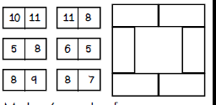
Show it: Can you find more addition statements. Represent all the ways to show the addition number sentences to make 16.

  
  
  
  

