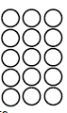
Do it
Calculate and represent
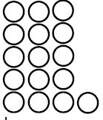
16 - = 16 - =

16 - = 16 - = 4

16 - = 16 - =

Show it: Can you find more subtraction facts. Represent all the ways to show the subtraction number sentences of 16.

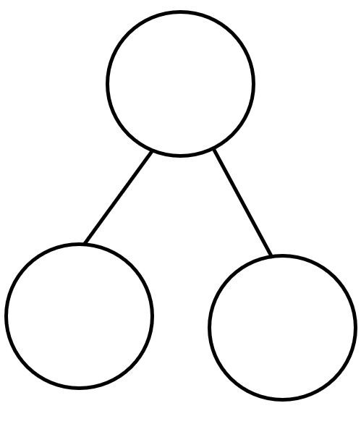
Secure it
Key words
16
8
8


Co Colin is incorrect because I know that ___ is the whole and
Colin thinks that:
8 = 8 - 16

Explain why he is incorrect.
Colin is incorrect because I know that _______ is the part that I am taking away from ______ and _______ is the part that I should have left

Correct number sentence:____________________________________________

Deepen it:
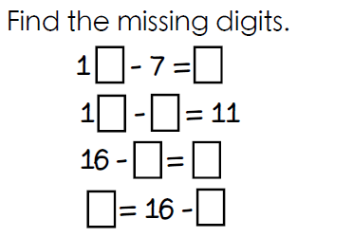
Solve it in several
different ways.

Solve it using
5, 6, 7, 8 and 9
at least once each

Show it: Can you find more subtraction statements. Represent all the ways to show the subtraction number sentences of 16.
___ - _____ =____
___ - _____ =____
___ - _____ =____
___ - _____ =____



