Do it
Tick which of these two sticks is longer.
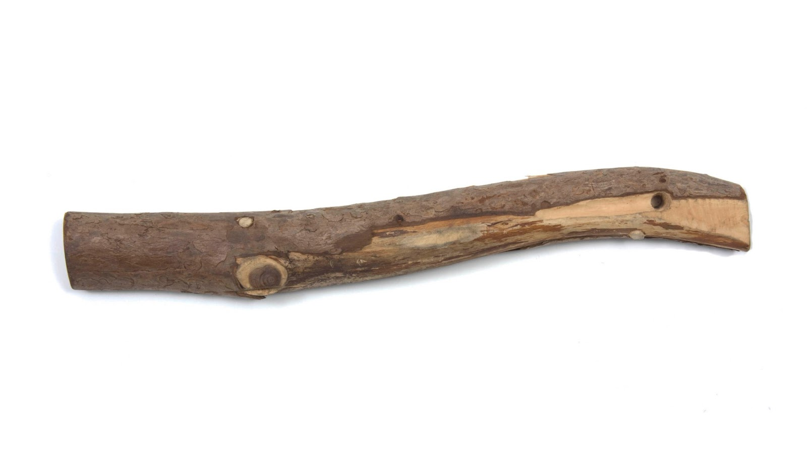

Tick which of these two ribbons is longer.
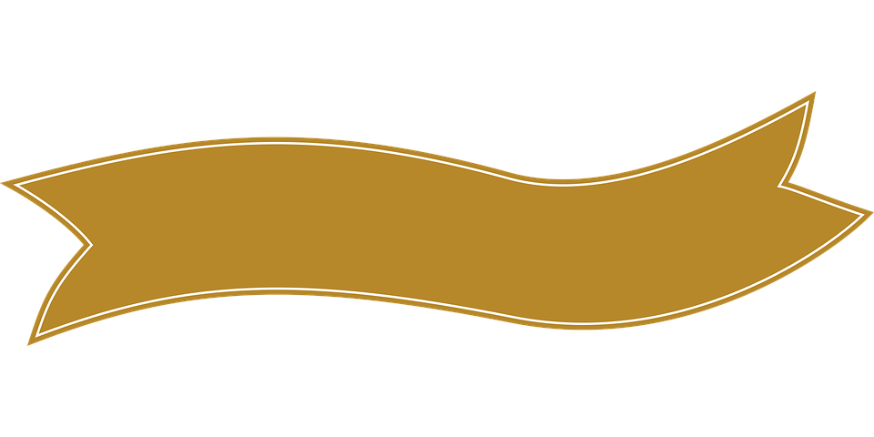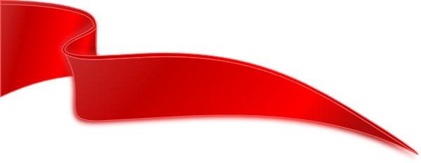
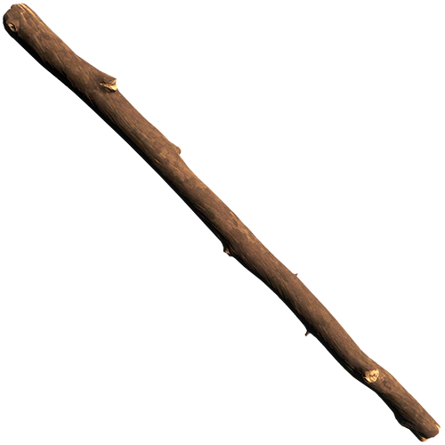

Tick which of these two pencils is longer.
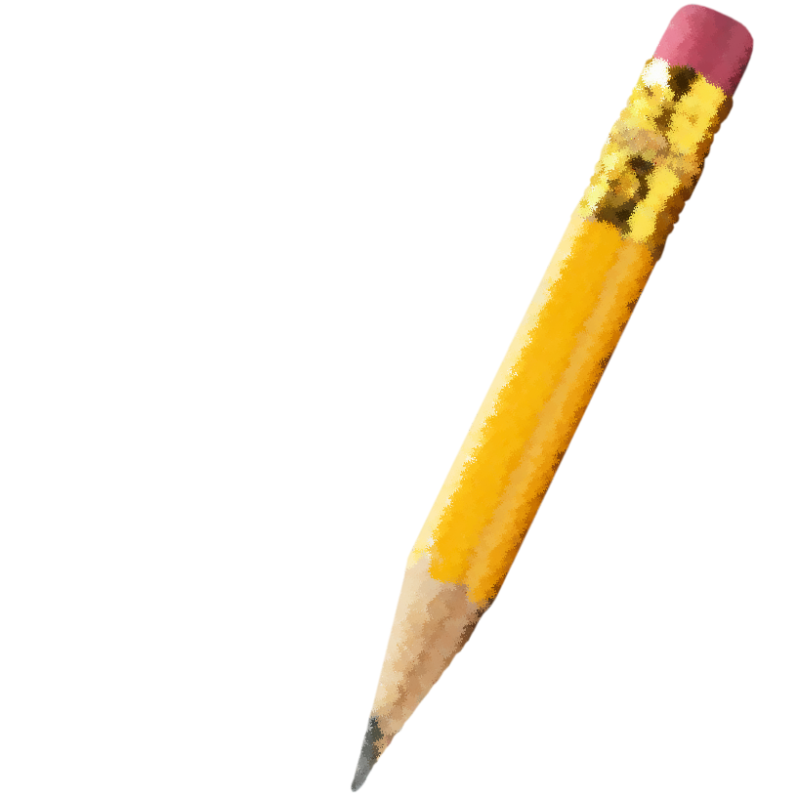

Tick which one of these two pencils is shorter.

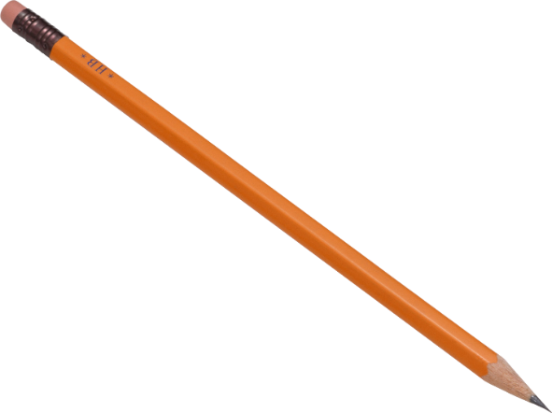
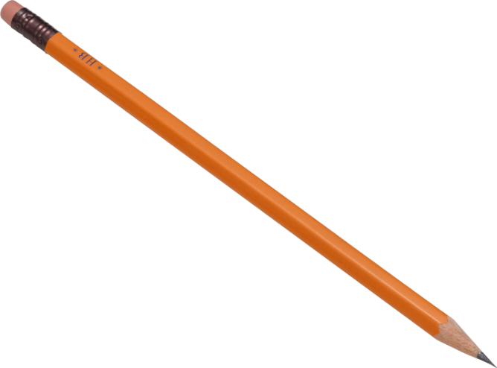

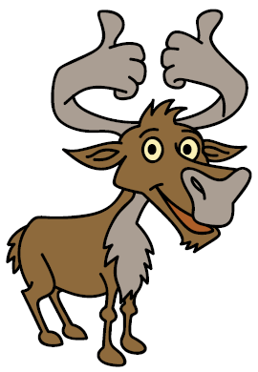
Secure it
Co Colin is incorrect because I know that ___ is the whole and
Key words
shorter
longer
Colin thinks that line B is longer than line A.
A
B
Explain why he is incorrect.

Explain why he is incorrect.
Colin is incorrect because Colin measured the lines from different starting points so I know that line A is ____________________ than

part and line B is ____________________ than line A.

Deepen it (Challenge):
- Find three objects that are different lengths, such as pencils. You will need to label them A, B and C with a piece of paper. Can you label them so that when A and B are put together they are still shorter than C. Can you take a picture to send to your teacher?

- Cut a piece of string into four pieces that are all different. You will need to label them A, B, C, D. Can you label them so that when A and B are put together they are longer than C and D together. Can you take a picture to send your teacher?

