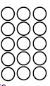
Do it
Can you put the objects or lines in order from shortest to the longest?
Lines

A _______________ Shortest

B ____________
C _________________________ Longest

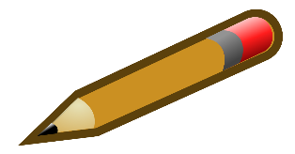
Pencils
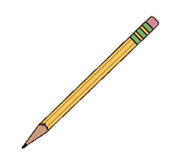
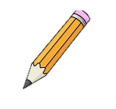
A Shortest

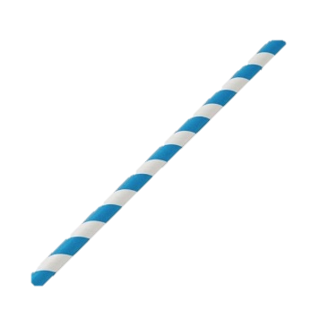
B

C Longest

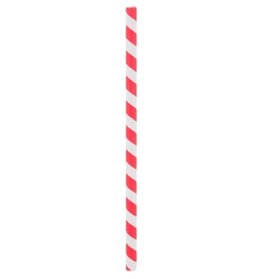
Straws

A Shortest

B

C Longest

Caterpillars
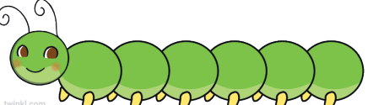
A Shortest

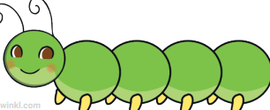
B

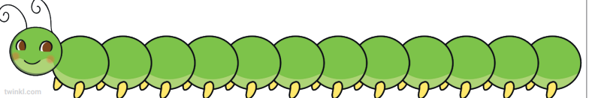
C Longest

Show it:
Length Hunt Can you find three objects in your house and order them from the shortest to the longest?
Secure it
Colin thinks that lines are in order from shortest to longest.
A
B
C
D
Co Colin is incorrect because I know that ___ is the whole and
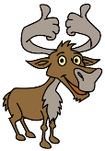

Explain why he is incorrect.
Colin is incorrect because Colin measured line C from a different starting point so line C

is not _________________ than the one before and __________________ than the one after.

Correct order from shortest to longest
Key words
longer
shorter

Line __________
Line __________
Line __________
Line __________

Deepen it:
Always/Sometimes/Never True
If four pencils are in order from shortest to longest, you need to swap two pencils so that they are in order from longest to shortest.


