Touch counting
Can you match the numerals to the amount of dots in the shapes?
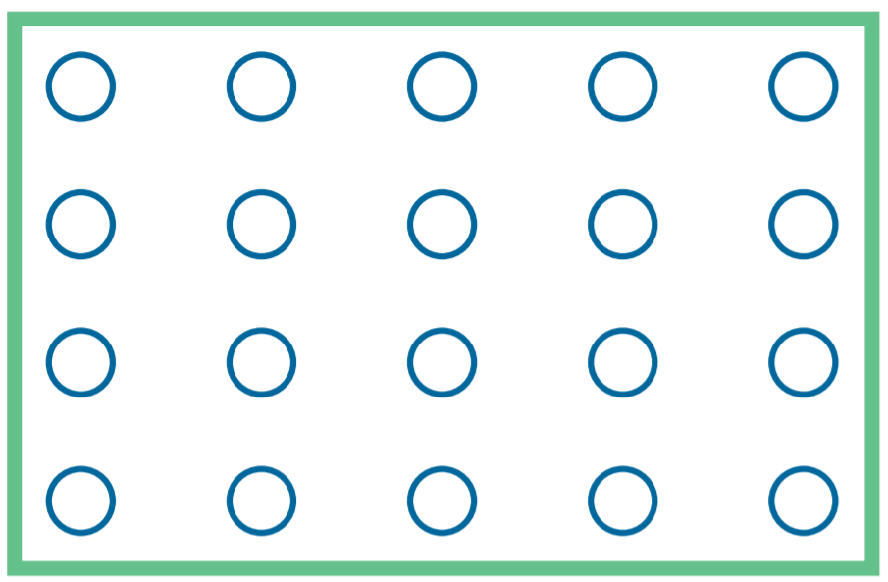 |  | 12
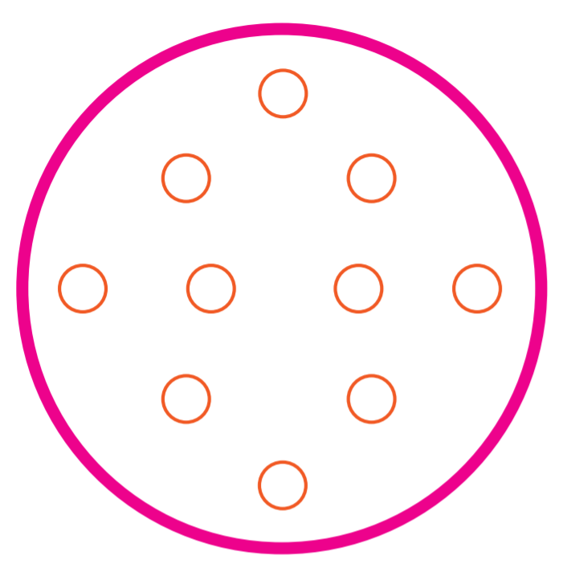 |  | 7
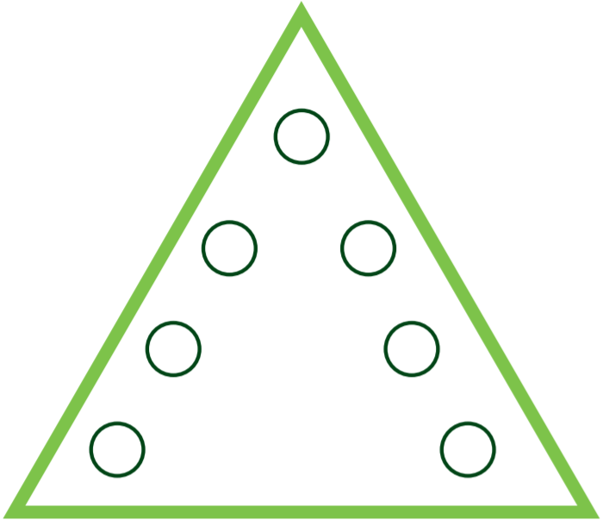 |  | 13
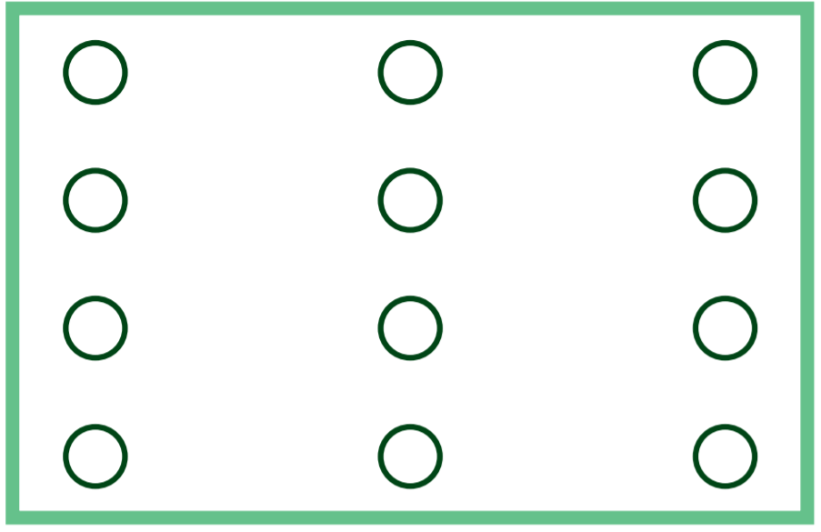 |  | 10
 |  | 20

Look at the picture below. Can you count how many of each object there are in the picture below?
Write the numeral in the box. Remember to cross out each item as you count it so that you don’t count it twice.


