Do it
Tick which of these two people is taller.

Tick which of these two towers is taller.
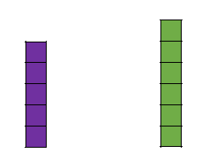





Tick which of these two towers is shorter.

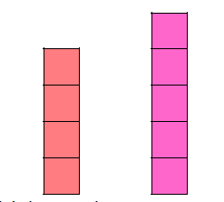
Tick which one of these two trees is shorter.

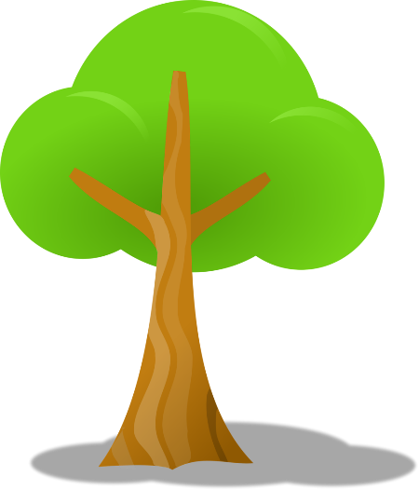


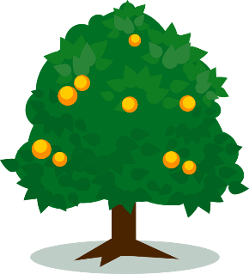

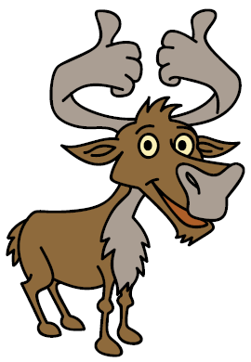
Secure it
Key words
shorter
taller
. 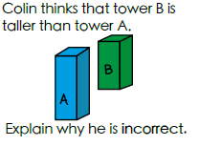

Explain why he is incorrect.
Co Colin is incorrect because I know that ___ is the whole and

Explain why he is incorrect.
Colin is incorrect because Colin measured the towers from different starting points so I know that tower A is ____________________ than tower B and tower B is ____________________ than tower A.

Deepen it (Challenge):
Always/Sometimes/Never True
Thinner objects are taller.
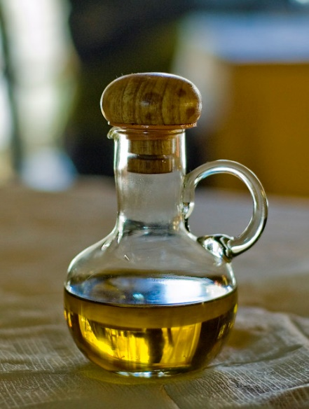
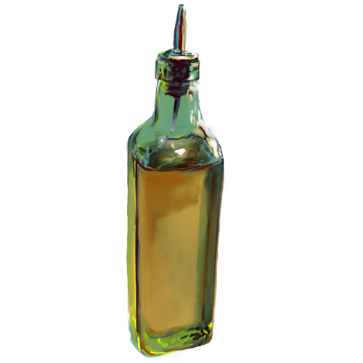
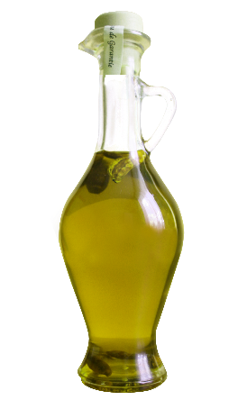

Investigate using items from your home.

